O’ZBEKISTON RESPUBLIKASI OLIY TA’LIM,FAN VA INNOVATSIYA
VAZIRLIGI
ABU RAYXON BERUNIY NOMIDAGI URGANCH DAVLAT
UNIVERSITETI

Kompyuter injineringgi fakulteti
“Kompyuter ilmlari va dasturlash texnologiyalari” yo’nalishi 234 guruh
Komilova Farangizning
“Web texnologiya ” fanidan
6-laboratoriya mashg’uloti

Qabul qildi:________________________________________________

Urganch-2026
6-Lobaratoriya.PHP orqali CRUD (Create, Read, Update, Delete) amallarini bajarish
Ishdan maqsad
- PHP va MySQL yordamida ma’lumotlar bazasi bilan ishlashni o‘rganish
- CRUD (Create, Read, Update, Delete) amallarini amalda bajarish
- HTML forma orqali ma’lumotlarni kiritish va qayta ishlash
- Ma’lumotlar bazasidagi yozuvlarni chiqarish, tahrirlash va o‘chirish
Kerakli dasturiy vositalar
- XAMPP / OpenServer / Denwer
- PHP 7.x yoki yuqori
- MySQL
- Brauzer (Chrome, Edge va h.k.)
- Kod muharriri (VS Code, Sublime va boshqalar)
Nazariy qism
CRUD tushunchasi
CRUD – bu ma’lumotlar bazasida bajariladigan 4 asosiy amal:
Amal | Tavsif
Create | Yangi ma’lumot qo‘shish
Read | Ma’lumotlarni o‘qish (ko‘rish)
Update | Ma’lumotni tahrirlash
Delete | Ma’lumotni o‘chirish

1-qadam: Ma’lumotlar bazasini yaratish
phpMyAdmin orqali quyidagi SQL so‘rovni bajaring:
CREATE DATABASE talaba_db;
USE talaba_db;
CREATE TABLE talabalar (
id INT AUTO_INCREMENT PRIMARY KEY,
ism VARCHAR(50) NOT NULL,
familiya VARCHAR(50) NOT NULL,
yosh INT NOT NULL
);
2-qadam: Loyihaning fayl tuzilmasi
crud/
│
├── db.php
├── index.php
├── add.php
├── edit.php
├── delete.php
3-qadam: Ma’lumotlar bazasiga ulanish (db.php)
<?php
$conn = new mysqli("localhost", "root", "", "talaba_db");
if ($conn->connect_error) {
die("Ulanishda xatolik: " . $conn->connect_error);
}
?>
4-qadam: CREATE – Ma’lumot qo‘shish (add.php)
<?php
include 'db.php';
if(isset($_POST['submit'])){
$ism = $_POST['ism'];
$familiya = $_POST['familiya'];
$yosh = $_POST['yosh'];
$sql = "INSERT INTO talabalar (ism, familiya, yosh)
VALUES ('$ism', '$familiya', '$yosh')";
$conn->query($sql);
header("Location: index.php");
}
?>
<form method="POST">
Ism: <input type="text" name="ism"><br>
Familiya: <input type="text" name="familiya"><br>
Yosh: <input type="number" name="yosh"><br>
<button type="submit" name="submit">Saqlash</button>
</form>
5-qadam: READ – Ma’lumotlarni chiqarish (index.php)
<?php include 'db.php'; ?>
<a href="add.php">Yangi talaba qo‘shish</a>
<table border="1">
<tr>
<th>ID</th>
<th>Ism</th>
<th>Familiya</th>
<th>Yosh</th>
<th>Amallar</th>
</tr>
<?php
$result = $conn->query("SELECT * FROM talabalar");
while($row = $result->fetch_assoc()){
echo "<tr>
<td>{$row['id']}</td>
<td>{$row['ism']}</td>
<td>{$row['familiya']}</td>
<td>{$row['yosh']}</td>
<td>
<a href='edit.php?id={$row['id']}'>Tahrirlash</a>
<a href='delete.php?id={$row['id']}'>O‘chirish</a>
</td>
</tr>";
}
?>
</table>
6-qadam: UPDATE – Ma’lumotni tahrirlash (edit.php)
<?php
include 'db.php';
$id = $_GET['id'];
$result = $conn->query("SELECT * FROM talabalar WHERE id=$id");
$row = $result->fetch_assoc();
if(isset($_POST['update'])){
$ism = $_POST['ism'];
$familiya = $_POST['familiya'];
$yosh = $_POST['yosh'];
$conn->query("UPDATE talabalar
SET ism='$ism', familiya='$familiya', yosh='$yosh'
WHERE id=$id");
header("Location: index.php");
}
?>
<form method="POST">
Ism: <input type="text" name="ism" value="<?php echo $row['ism']; ?>"><br>
Familiya: <input type="text" name="familiya" value="<?php echo $row['familiya']; ?>"><br>
Yosh: <input type="number" name="yosh" value="<?php echo $row['yosh']; ?>"><br>
<button type="submit" name="update">Yangilash</button>
</form>
7-qadam: DELETE – Ma’lumotni o‘chirish (delete.php)
<?php
include 'db.php';
$id = $_GET['id'];
$conn->query("DELETE FROM talabalar WHERE id=$id");
header("Location: index.php");
?>
Topshiriqlar:
10.TOPSHIRIQ: “Elektron Ombor”
Database: inventory_storage_db
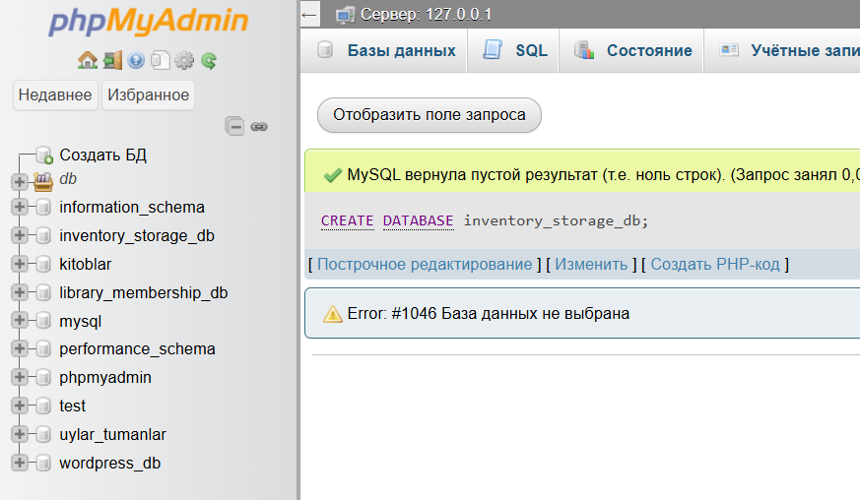
Jadval: stock_entries
Ustunlar:
- entry_id
- product_label
- unit_measure
- quantity_amount
- supply_date
- expiration_date
- vendor_company
- storage_section
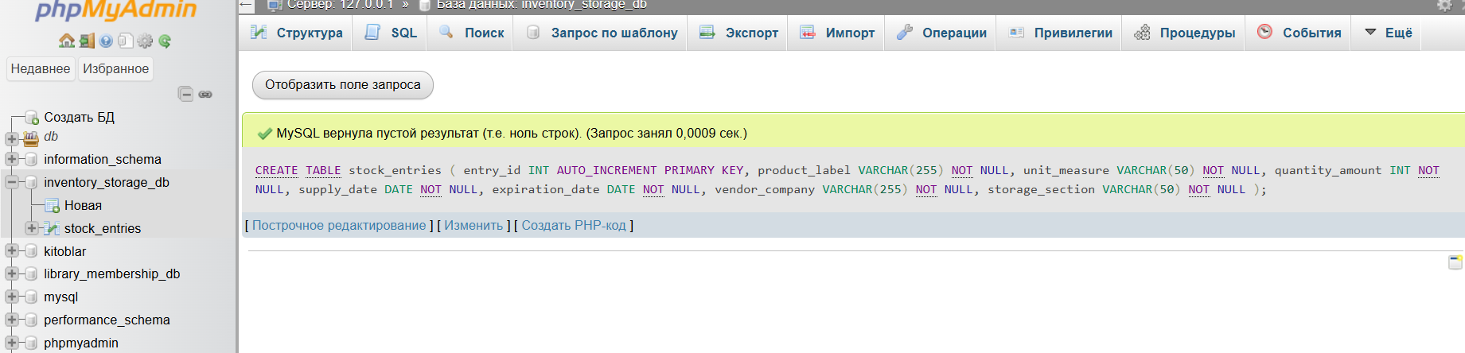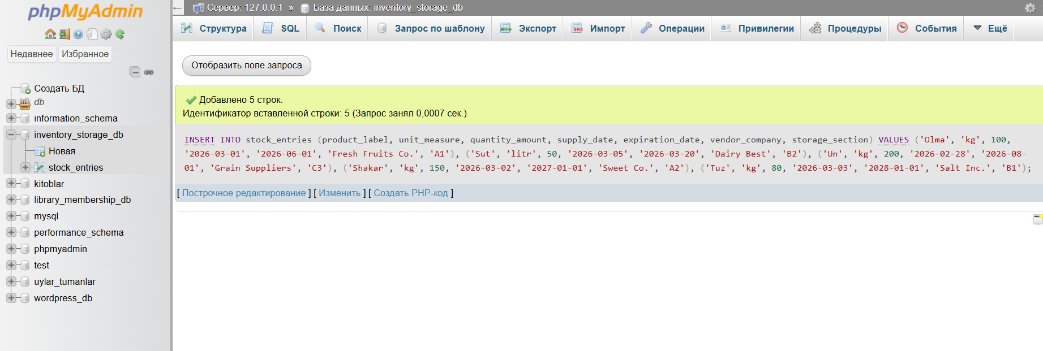
Kodi
<?php
// 1. Databasega ulanish
$host = "localhost";
$user = "root";
$password = "";
$dbname = "inventory_storage_db";

$conn = new mysqli($host, $user, $password, $dbname);
if ($conn->connect_error) {
die("Ulanishda xatolik: " . $conn->connect_error);
}
// 2. Ma'lumotlarni olish
$sql = "SELECT * FROM stock_entries ORDER BY entry_id ASC";
$result = $conn->query($sql);
?>
<!DOCTYPE html>
<html lang="uz">
<head>
<meta charset="UTF-8">
<meta name="viewport" content="width=device-width, initial-scale=1.0">
<title>Elektron Ombor - Stock Entries</title>
<link href="https://cdn.jsdelivr.net/npm/bootstrap@5.3.2/dist/css/bootstrap.min.css" rel="stylesheet">
<style>
body {
background: linear-gradient(120deg, #c3f0ca, #96e6b3);
font-family: Arial, sans-serif;
}
h2 {
text-align: center;
margin: 30px 0;
color: #2c3e50;
text-shadow: 1px 1px #fff;
}
.container {
background-color: rgba(255,255,255,0.95);
padding: 30px;
border-radius: 15px;
box-shadow: 0 8px 25px rgba(0,0,0,0.3);
}
.table thead th {
background-color: #2c3e50;
color: #fff;
text-transform: uppercase;
}
.table-striped>tbody>tr:nth-of-type(odd) { background-color: #e0f7fa; }
.table-striped>tbody>tr:nth-of-type(even) { background-color: #b2ebf2; }
.table-hover tbody tr:hover { background-color: #4dd0e1; font-weight:bold; }
</style>
</head>
<body>
<div class="container">
<h2>Elektron Ombor - Stock Entries</h2>
<div class="table-responsive">
<table class="table table-bordered table-striped table-hover shadow-sm">
<thead>
<tr>
<th>ID</th>
<th>Mahsulot nomi</th>
<th>O‘lchov birligi</th>
<th>Miqdori</th>
<th>Ta’minot sanasi</th>
<th>Amal qilish muddati</th>
<th>Yetkazib beruvchi kompaniya</th>
<th>Ombor bo‘limi</th>
</tr>
</thead>
<tbody>
<?php if ($result->num_rows > 0): ?>
<?php while($row = $result->fetch_assoc()): ?>
<tr>
<td><?php echo $row['entry_id']; ?></td>
<td><?php echo $row['product_label']; ?></td>
<td><?php echo $row['unit_measure']; ?></td>
<td><?php echo $row['quantity_amount']; ?></td>
<td><?php echo $row['supply_date']; ?></td>
<td><?php echo $row['expiration_date']; ?></td>
<td><?php echo $row['vendor_company']; ?></td>
<td><?php echo $row['storage_section']; ?></td>
</tr>
<?php endwhile; ?>
<?php else: ?>
<tr><td colspan="8" class="text-center">Ma’lumot topilmadi</td></tr>
<?php endif; ?>
</tbody>
</table>
</div>
</div>
<script src="https://cdn.jsdelivr.net/npm/bootstrap@5.3.2/dist/js/bootstrap.bundle.min.js"></script>
</body>
</html>
<?php
$conn->close();
?>

Natijasi
